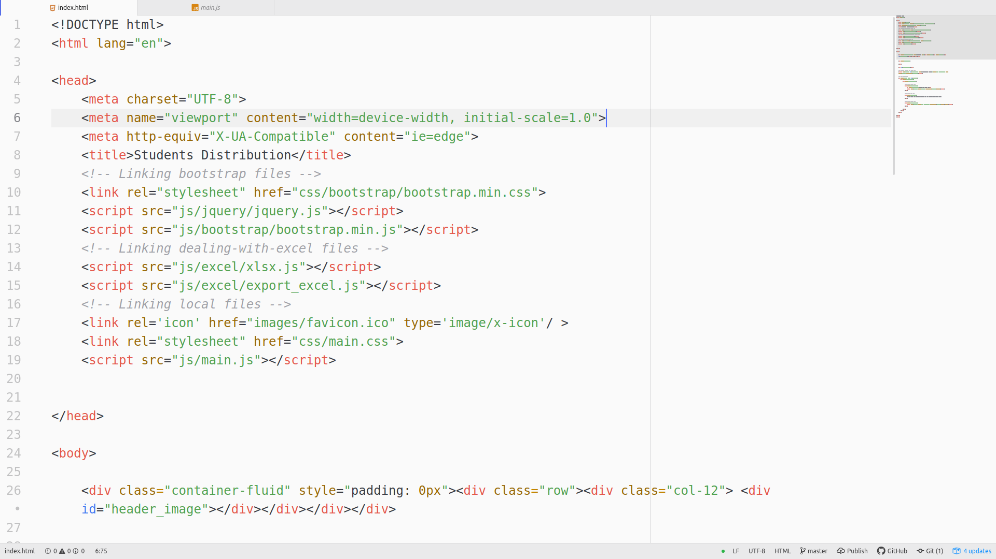
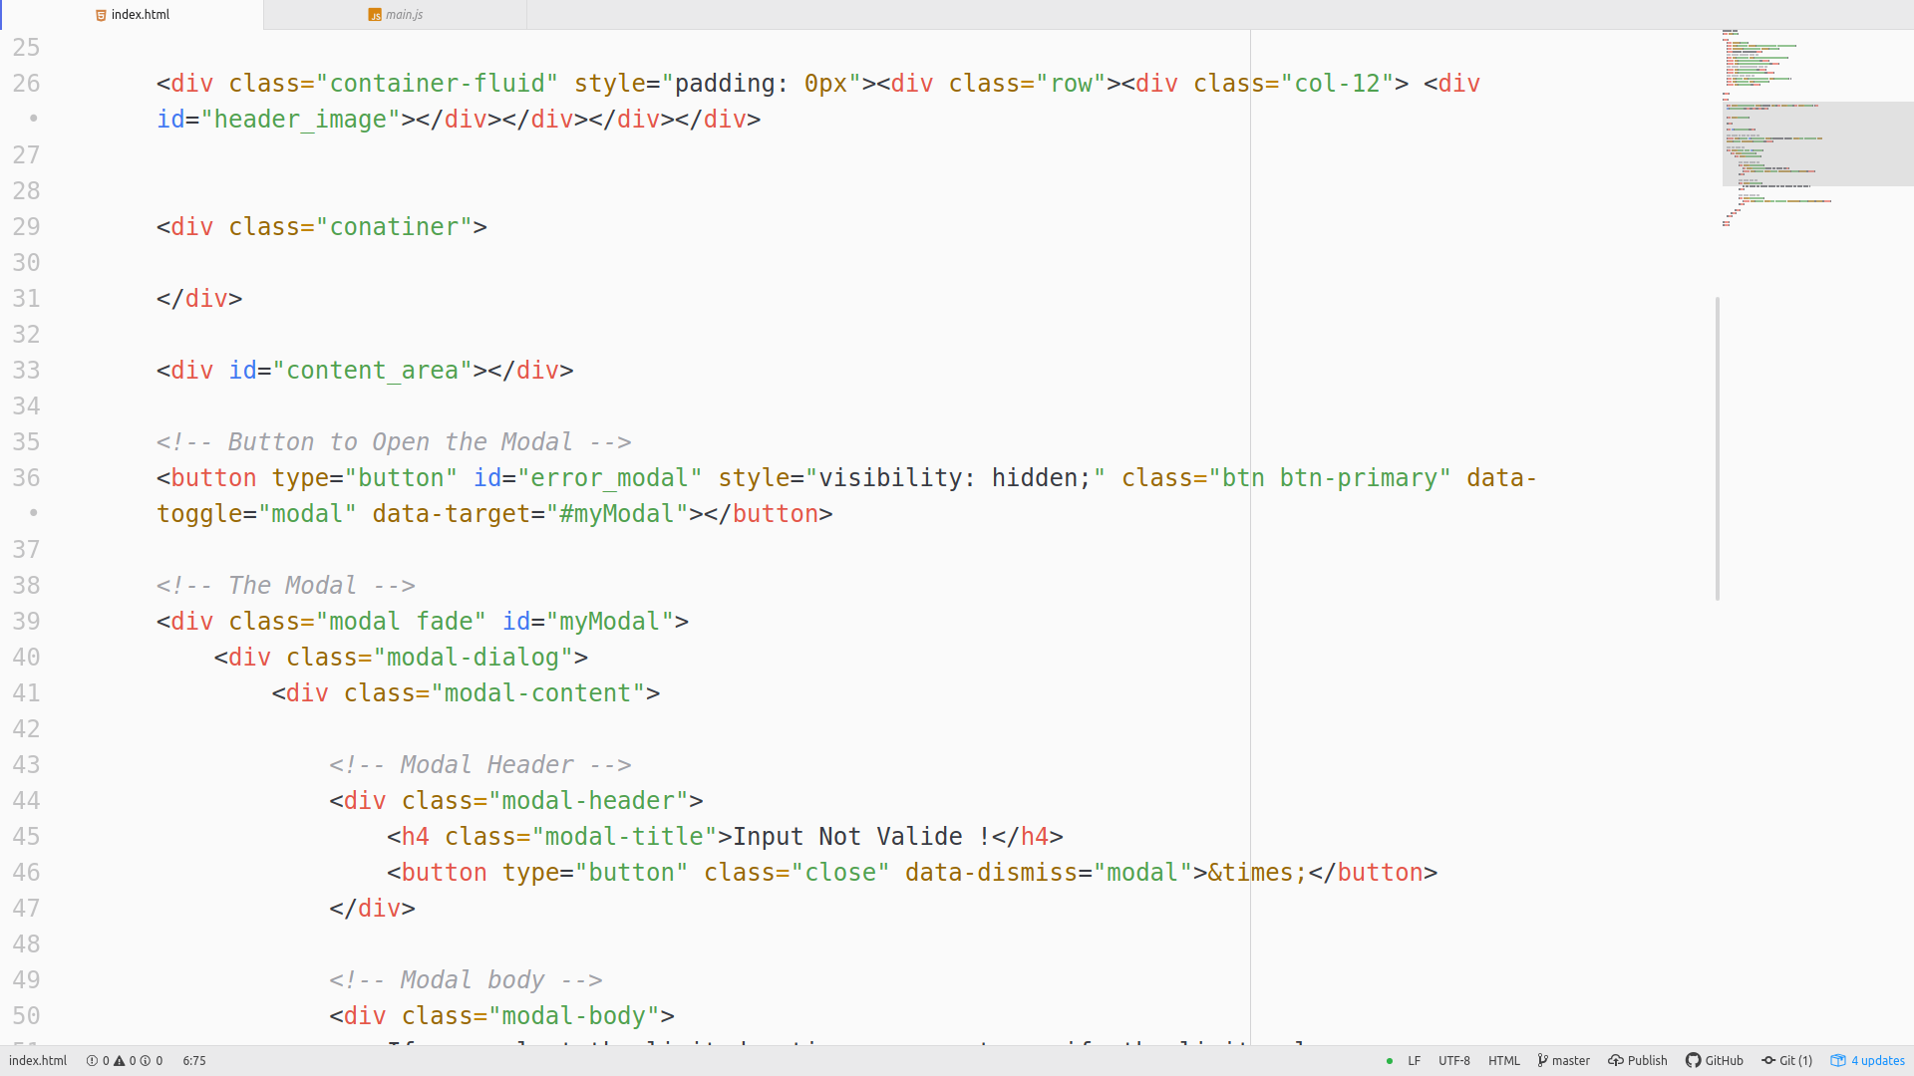

==> HTML document for layout and linking with JavaScript and CSS libraries.

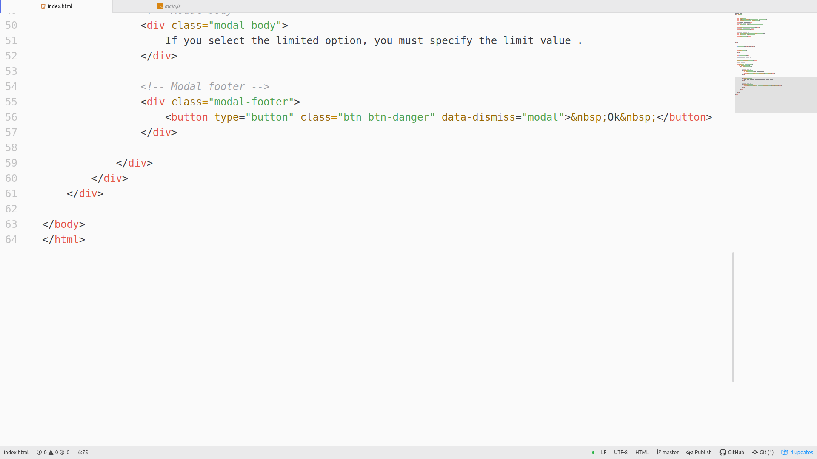

The project consists of four classes:

1- Class for dealing with the user input file (File)
this class is used to keep track of the excl file the user inputs and all the file information and methods.
Class methods:
** handle_file (file) ==> converts the excel file data into json format, called when the user inputs the excel file.
** export_excel (department_students, department_name) ==> enables the user to download the excel file, called when the user click export button.
** create_students_objects () ==> creates objects from Student class to represent the students in the excel file.
** validate_user_options (user_options) ==> prevents users from entering non-valide options.
** distribute (user_options) ==>
loop through each student:
loop through the student wish:
- if the wish department is unlimited then distribute the student to this department.
Then increase the population in this department by one, go to the next student.
- if the wish department is limited:
- if not full then distribute the student to this department.
Then increase the population in this department by one, go to the next student.
- if full then go to the second wish

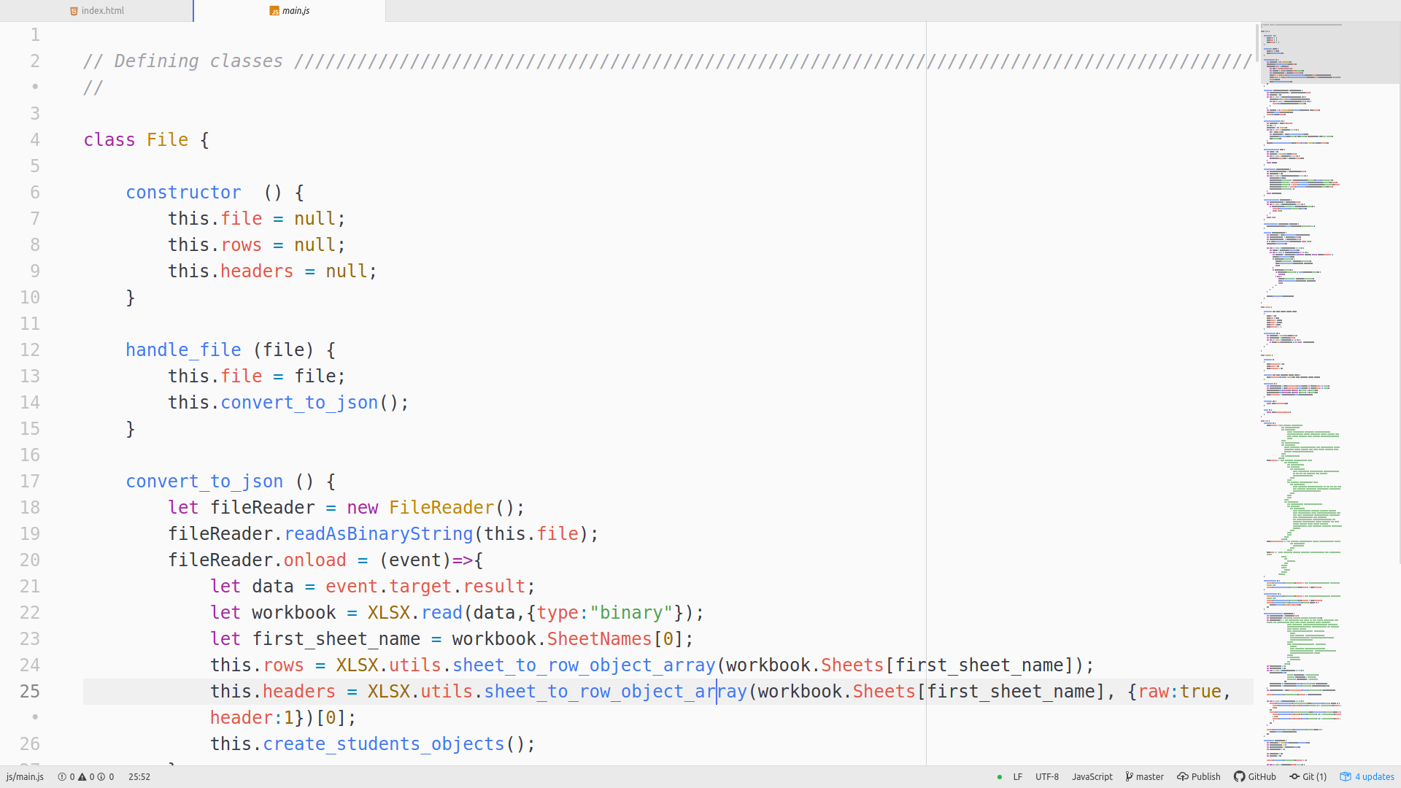

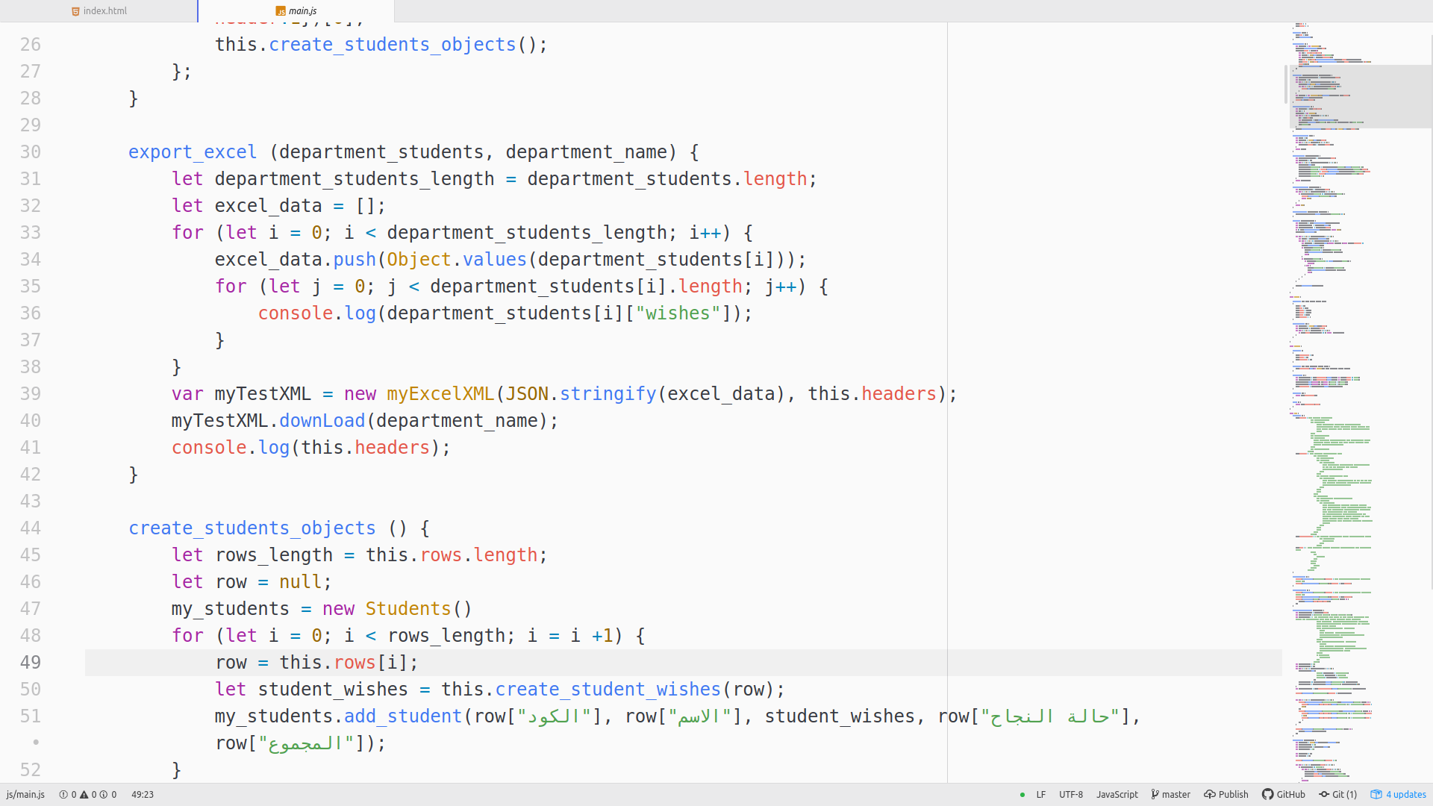

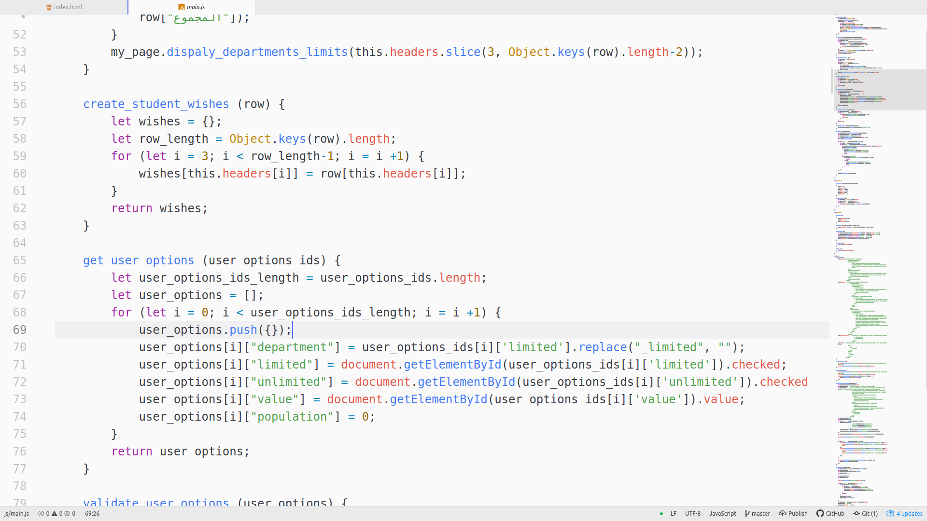

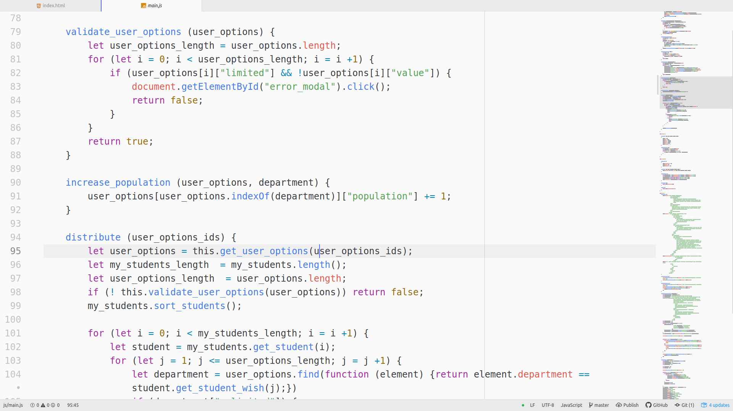

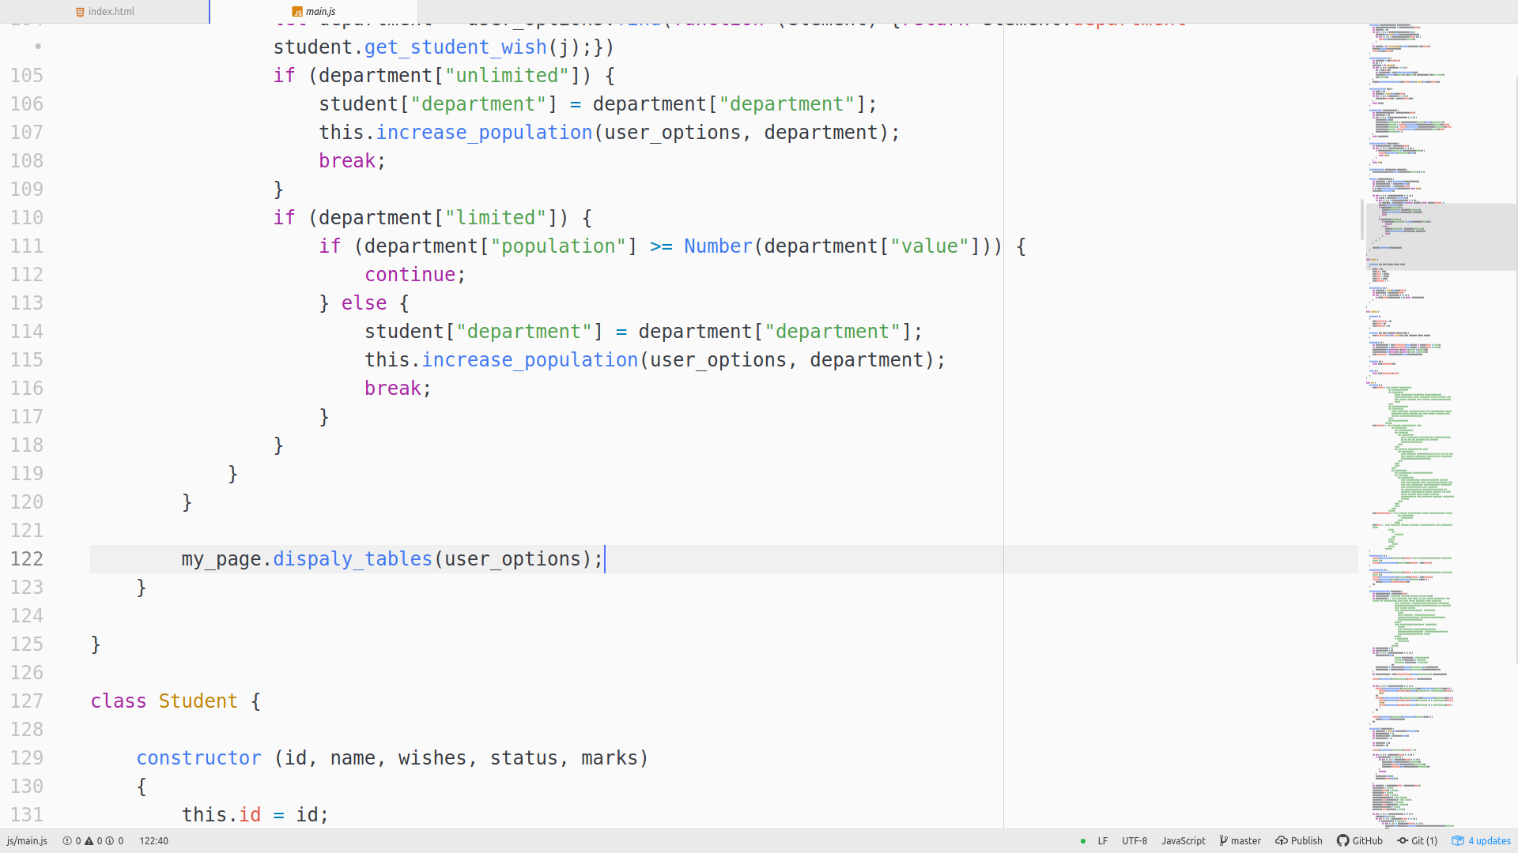

2- Class for tracking student data (Student)
this class is used to keep track of the student data.
Class methods:
** get_student_wish (i) ==> return the student wish number I.

3- Class for tracking a list of all students (Students)
this class is used to keep track of a list of all students.
Class methods:
** sort_students () ==> sorts all students according their marks and status.

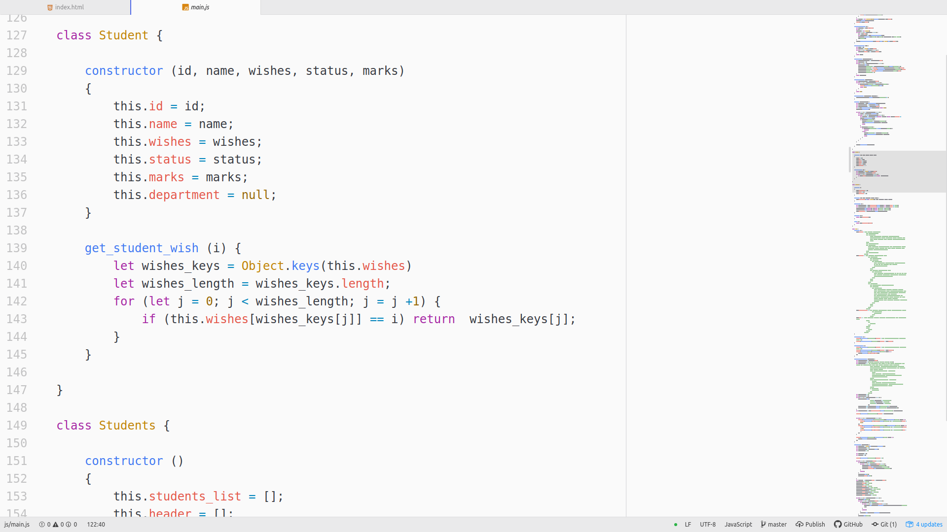

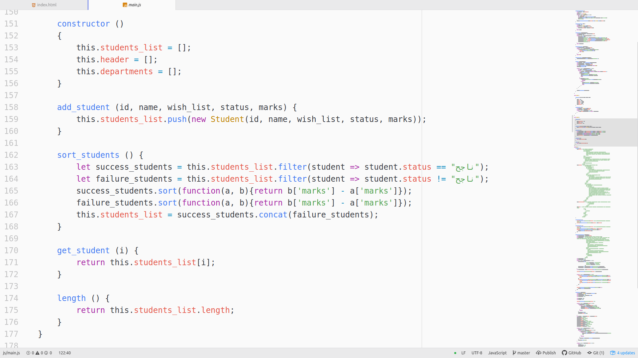

4- Class for representing the html page (Page)
this class is used to display html page components.
Class methods:
** display_main_page () ==> displays the page where you can select “RESULTS” or “DEPARTMENT”.
** display_start_page () ==> displays the page where you can upload the excel file.
** display_departments_limits (departments) ==> when the user upload the excel file, this method is called to enable the user to specify the limits of each department.
** display_tables () ==> when the user click “distribute” button, this method is called to display all students within the department where they are distributed.
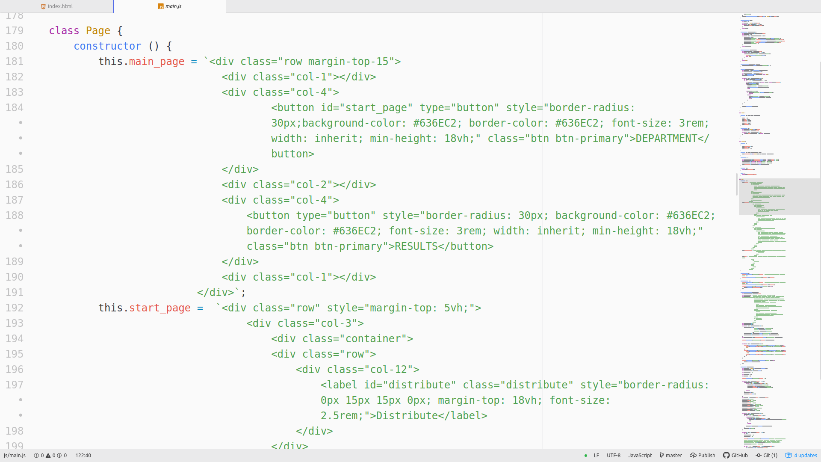

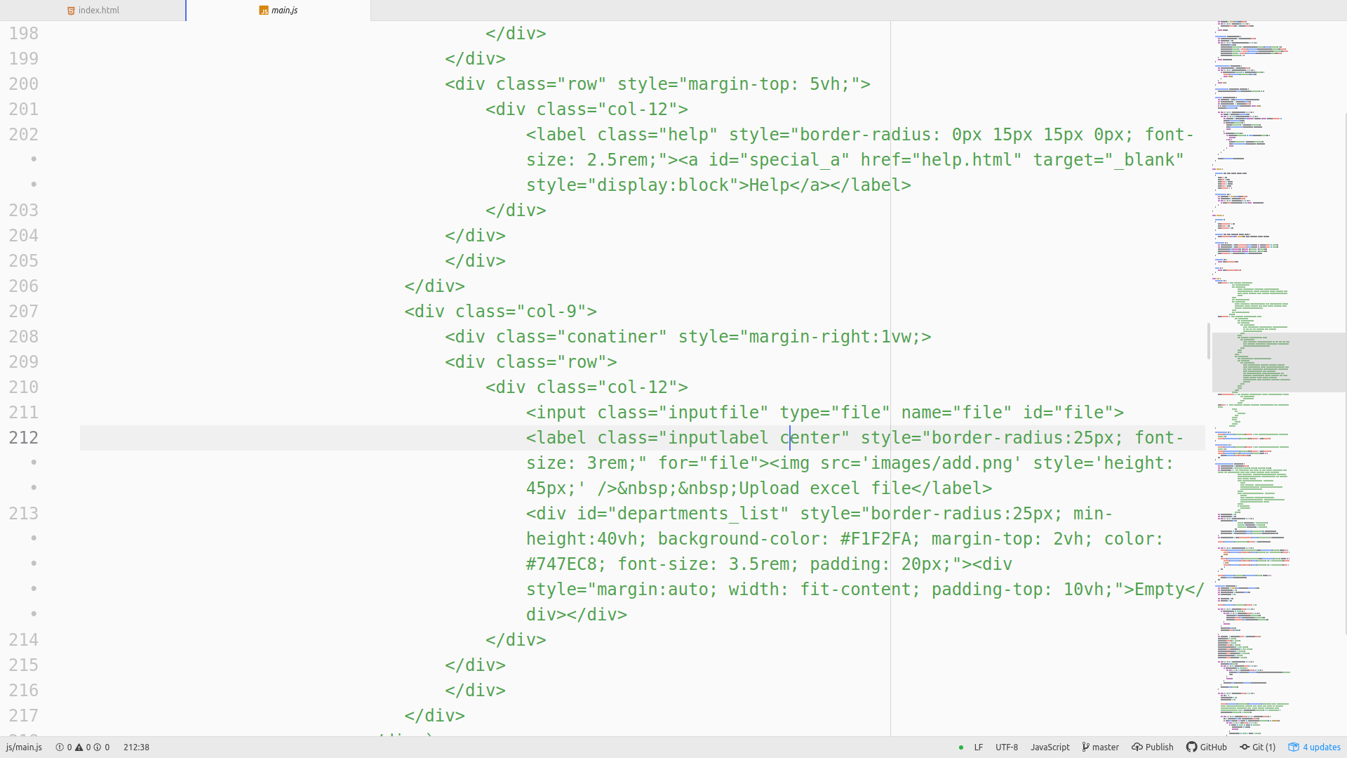

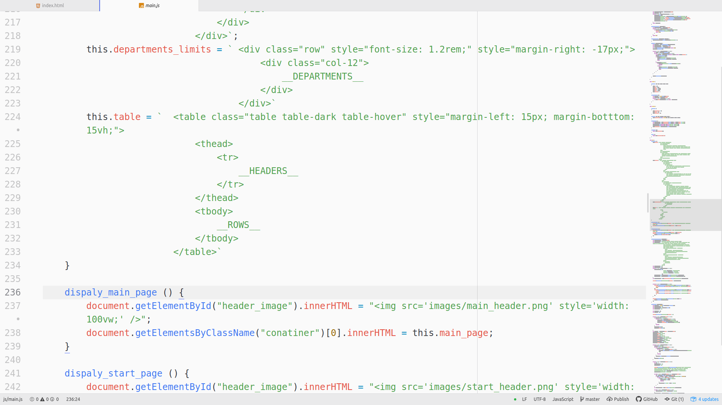

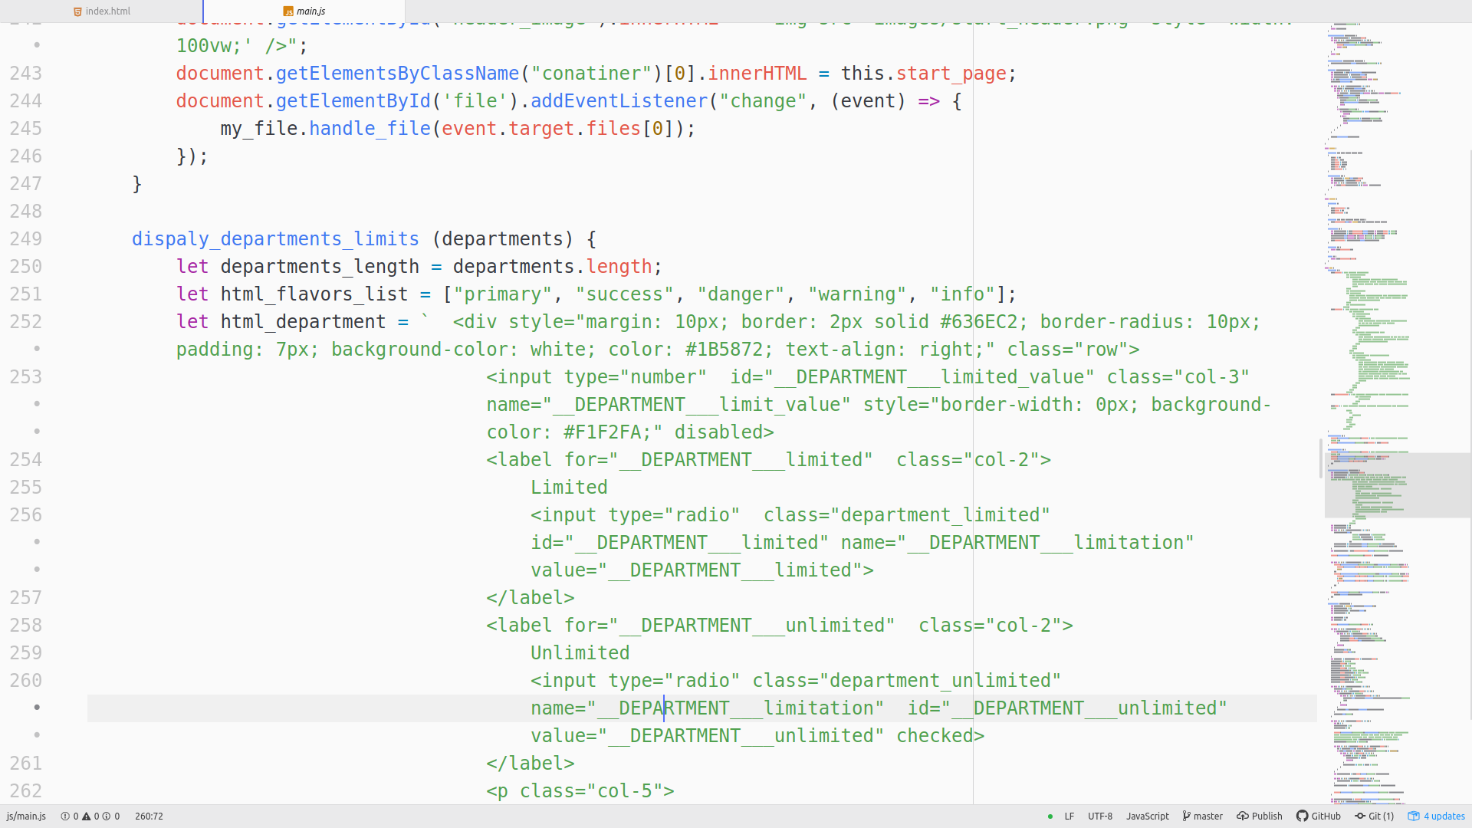

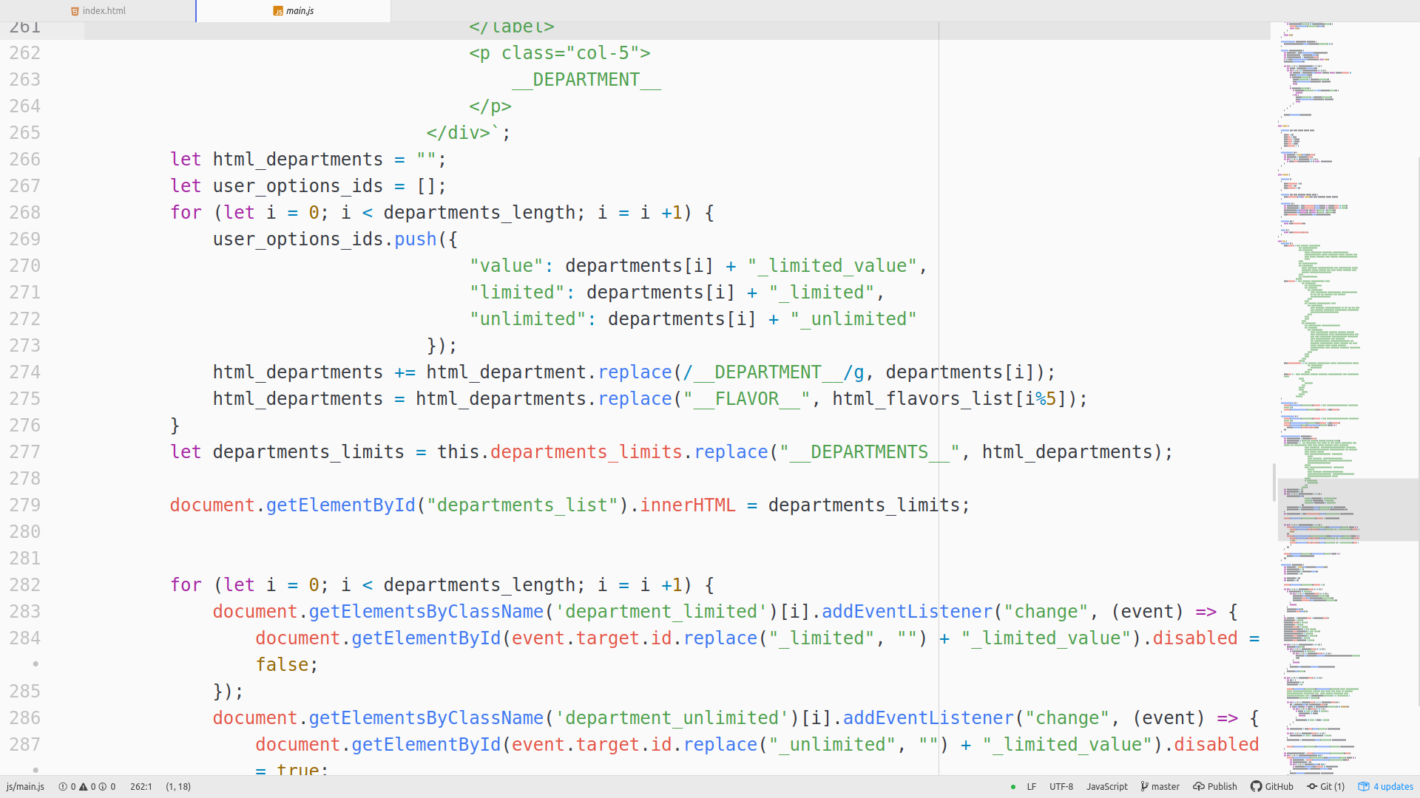

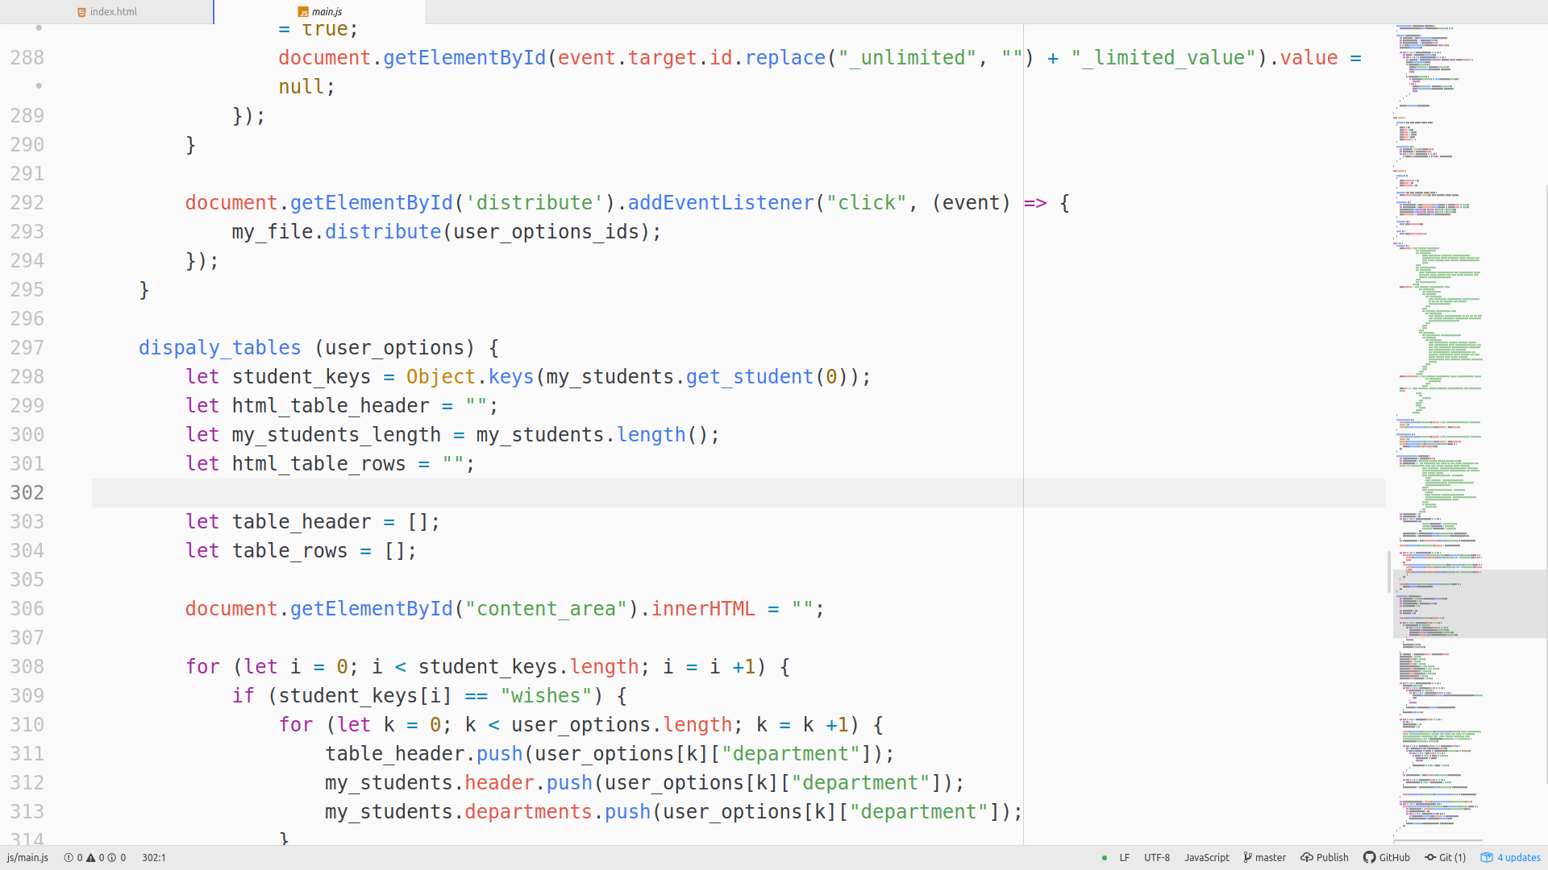

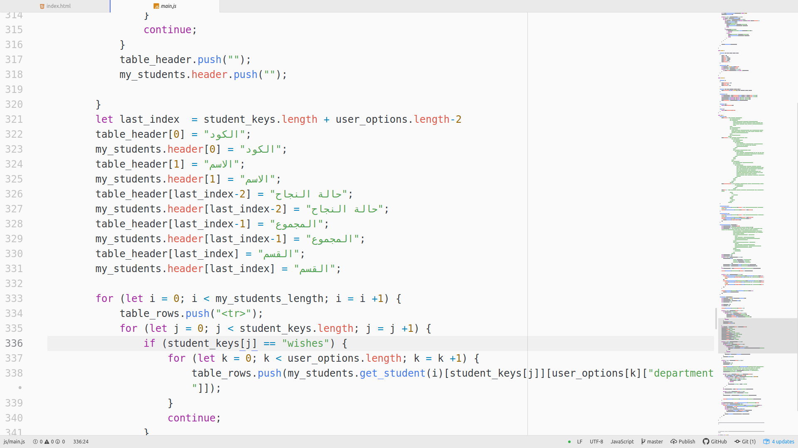
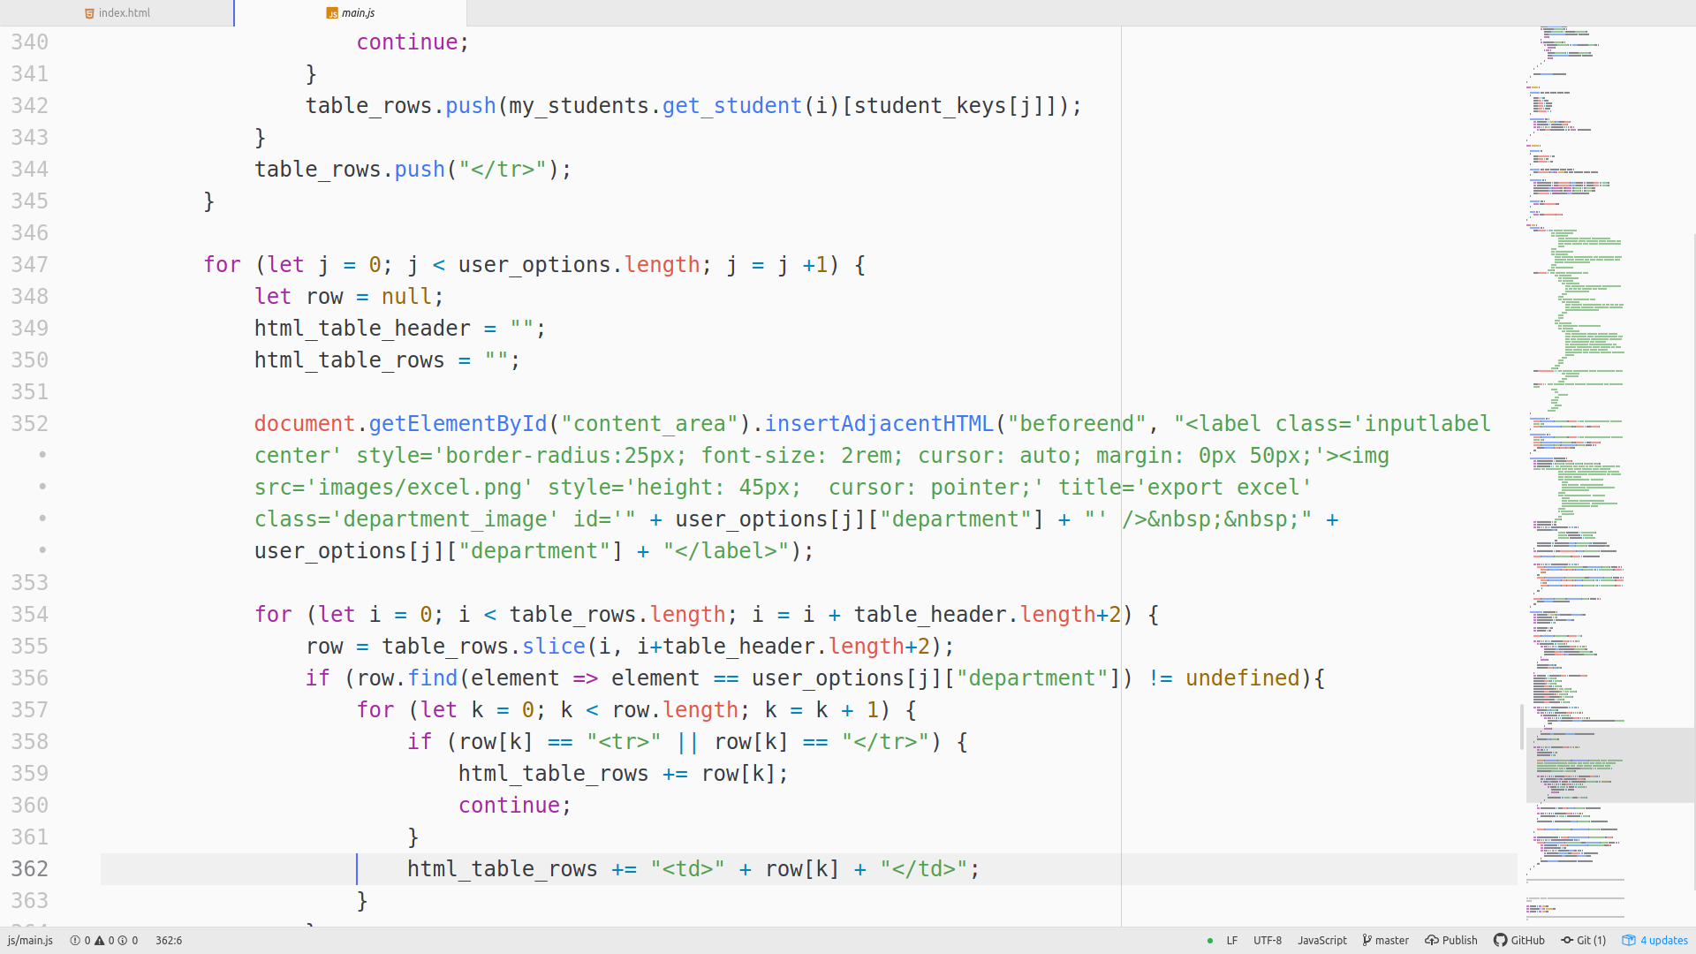

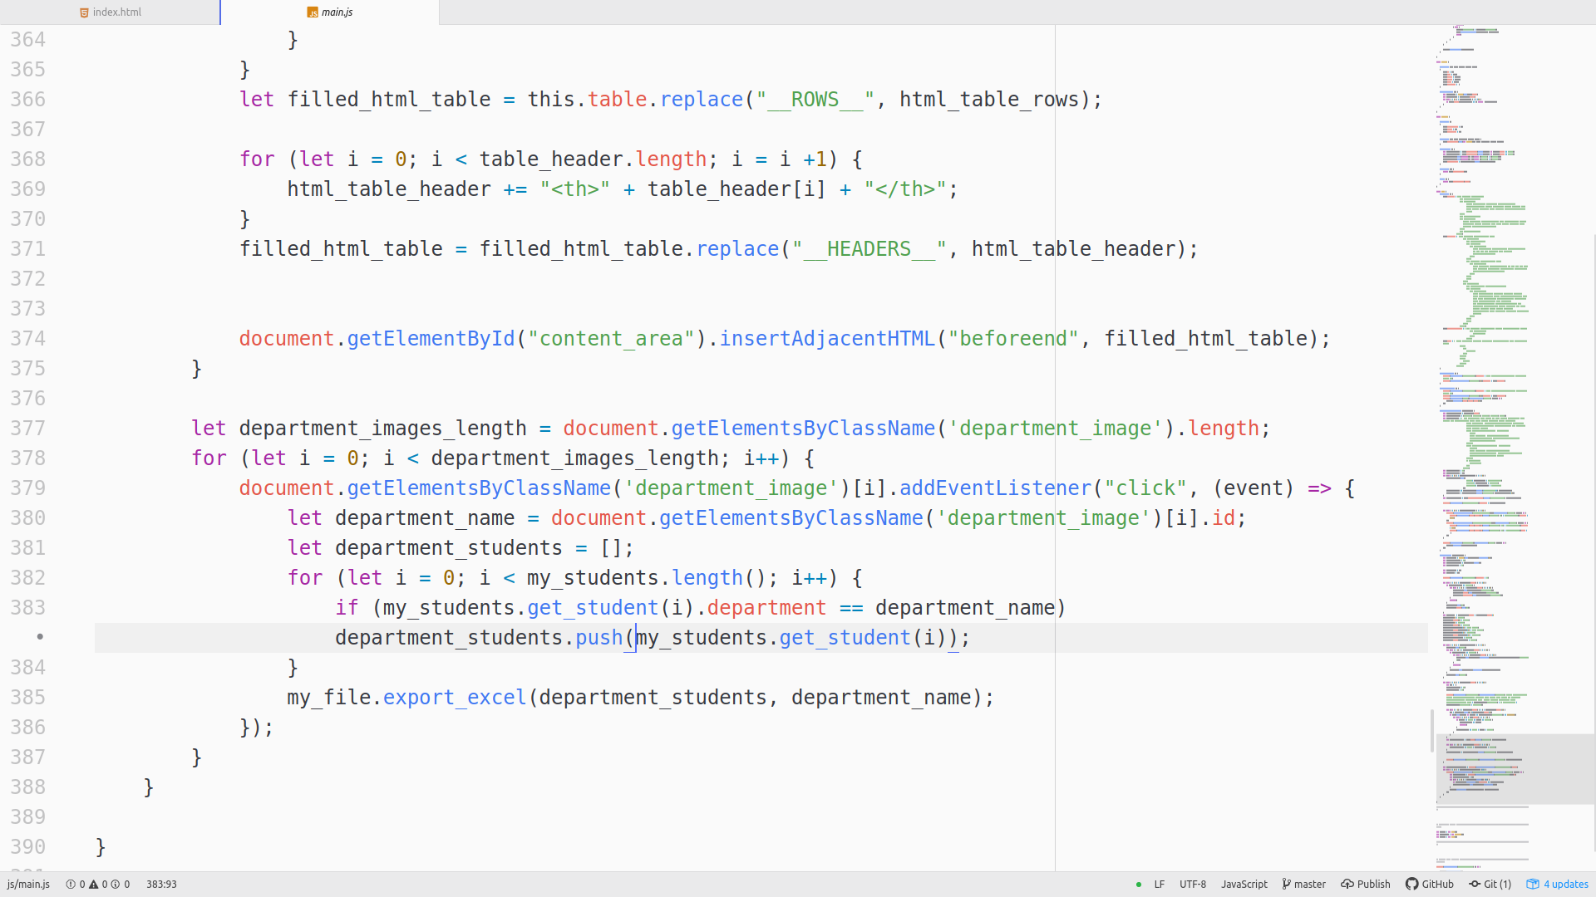

==> The control point of the whole program



